# **SQL Assignment – 2**

# **Task 1:- Understanding the Data**

# **Describe the data in hand in your own words.**

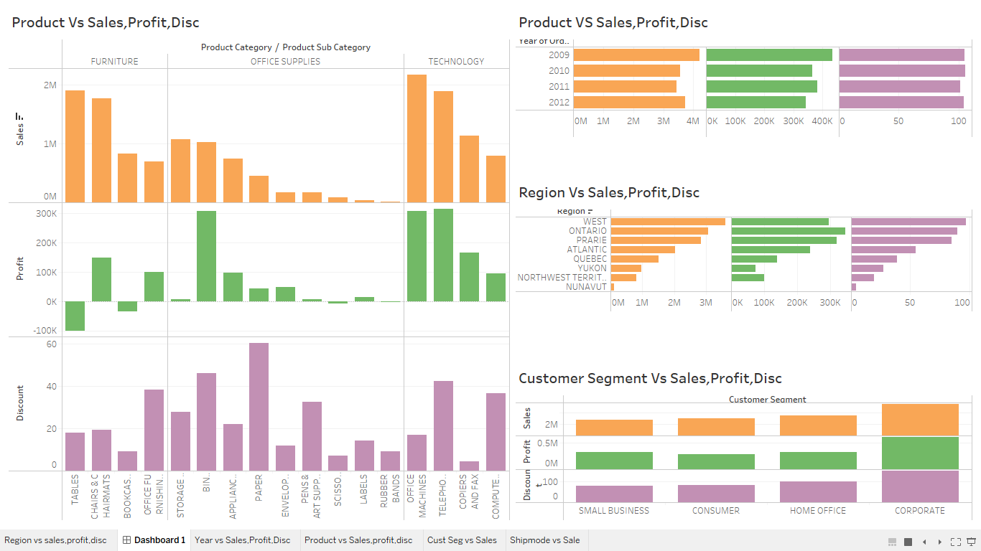

* **Comparing to all the years 2009 have the Highest Sales -> 4,209,139**
* **Comparing to all the years 2009 have the Highest Profit -> 4,34,539**
* **Comparing to all the years 2010 have the Highest Discount -> 105.780**
* **Comparing that 2011 year have recorded as the Lowest Sales -> 3,436,817**
* **Comparing that 2009 year have recorded as the Lowest Profit -> 4,31,902**
* **Comparing that 2009 year have recorded as the Lowest Discount -> 101.740**
* **Sub-Category Corporate Have the Highest Sales – 5,498,905**
* **Sub-Category Small Business have the Lowest Sales – 2,788,321**
* **Sub-Category Corporate have the highest Profit – 5,99,746**
* **Sub-Category Consumer have the Lowest Profit – 2,87,960**
* **Sub-Category Corporate have the Highest Discount – 153.31**
* **Sub-Category Small Business have the Lowest Discount – 81.12**

**LINK** [SQL Project Data | Tableau Public](https://public.tableau.com/app/profile/mantha.govardhan.gopi/viz/SQLProjectData/Dashboard1?publish=yes)

# **2.Identify and list the primary keys and Foreign Keys for this Dataset**

**1. Cust_dimen**

**Primary Key** :- Cust_id

**Foreign Key** :- NA

**2. market_fact**

**Primary Key** :- NA

**Foreign Key** :- Ord_id.Prod_id,Ship_id,Cust_id

**3. Orders_dimen**

**Primary Key** :- Ord_id

**Foreign Key** :- NA

**4. Prod_dimen**

**Primary Key** :- Prod_id,Product_sub_category.

**Foreign Key** :- NA

**5. Shipping_dimen**

**Primary Key** :- Ship_id

**Foreign Key** :- NA

1. Write a query to display the Customer_Name and Customer Segment using alias name “Customer Name", "Customer Segment" from table Cust_dimen.

SELECT

Customer_Name AS 'Customer Name',

Customer_Segment AS 'Customer Segment'

FROM

superstores.cust_dimen;

1. Write a query to find all the details of the customer from the table cust_dimen order by desc.

SELECT

*

FROM

superstores.cust_dimen

ORDER BY Customer_Name DESC;

1. Write a query to get the Order ID, Order date from table orders_dimen where ‘Order Priority’ is high.

SELECT

Order_ID, Order_Date

FROM

superstores.orders_dimen

WHERE

Order_Priority = 'HIGH';

1. Find the total and the average sales (display total_sales and avg_sales)

SELECT

ROUND(SUM(sales), 4) AS total_sales,

ROUND(AVG(sales), 4) AS avg_sales

FROM

superstores.market_fact;

1. Write a query to get the maximum and minimum sales from maket_fact table.

SELECT

MAX(sales) AS 'Maximum_sales', MIN(sales) AS 'Minimum_sales'

FROM

superstores.market_fact;

1. Display the number of customers in each region in decreasing order of no_of_customers. The result should contain columns Region, no_of_customers.

SELECT

region, COUNT(Cust_id) no_of_customers

FROM

superstores.cust_dimen

GROUP BY region

ORDER BY no_of_customers DESC;

1. Find the region having maximum customers (display the region name and max(no_of_customers)

SELECT

region, (COUNT(Cust_id)) 'max_no_of_customers'

FROM

superstores.cust_dimen

GROUP BY region

ORDER BY max_no_of_customers DESC

LIMIT 1;

1. Find all the customers from Atlantic region who have ever purchased ‘TABLES’ and the number of tables purchased (display the customer name, no_of_tables purchased)

SELECT

CD.Customer_name, COUNT(*) number_of_tables_purchased

FROM

superstores.market_fact AS MF

JOIN

superstores.cust_dimen AS CD ON MF.cust_id = CD.cust_id

WHERE

CD.Region = 'Atlantic'

AND MF.Prod_id = (SELECT

prod_id

FROM

superstores.prod_dimen

WHERE

product_sub_category = 'tables')

GROUP BY MF.Cust_id , CD.Customer_Name;

1. Find all the customers from Ontario province who own Small Business. (display the customer name, no of small business owners)

SELECT

customer_name, COUNT(Customer_Name)

FROM

superstores.cust_dimen

WHERE

Province = 'Ontario'

AND Customer_Segment = 'SMALL BUSINESS';

1. Find the number and id of products sold in decreasing order of products sold (display product id, no_of_products sold)

SELECT

Prod_id AS product_id, COUNT(*) AS no_of_products_sold

FROM

superstores.market_fact

GROUP BY Prod_id

ORDER BY no_of_products_sold DESC;

1. Display product Id and product sub category whose produt category belongs to Furniture and Technlogy. The result should contain columns product id, product sub category.

SELECT

prod_id AS product_id,

Product_Sub_Category AS product_Sub_category

FROM

superstores.prod_dimen

WHERE

Product_Category = 'FURNITURE'

AND product_category = 'TECHNOLOGY';

1. Display the product categories in descending order of profits (display the product category wise profits i.e. product_category, profits)?

SELECT

PD.Product_Category, SUM(MF.Profit) AS profits

FROM

superstores.prod_dimen AS PD

JOIN

superstores.market_fact AS MF ON PD.prod_id = MF.prod_id

GROUP BY PD.Product_Category

ORDER BY Profits DESC;

1. Display the product category, product sub-category and the profit within each subcategory in three columns.

SELECT

PD.product_category, PD.Product_Sub_Category, SUM(MF.Profit)

FROM

superstores.prod_dimen AS PD

JOIN

superstores.market_fact AS MF ON PD.prod_id = MF.prod_id

GROUP BY PD.Product_Category , PD.Product_Sub_Category;

1. Display the order date, order quantity and the sales for the order.

SELECT

OD.Ord_id,

OD.order_date,

MF.Order_Quantity,

SUM(MF.Sales) AS sales

FROM

superstores.orders_dimen AS OD

JOIN

superstores.market_fact AS MF ON OD.ord_id = MF.ord_id

GROUP BY OD.ord_id;

1. Display the names of the customers whose name contains the i) Second letter as ‘R’ ii) Fourth letter as ‘D’

SELECT

*

FROM

superstores.cust_dimen

WHERE

SUBSTR(customer_name, 2, 1) = 'R'

AND SUBSTR(customer_name, 4, 1) = 'D';

1. Write a SQL query to to make a list with Cust_Id, Sales, Customer Name and their region where sales are between 1000 and 5000.

SELECT

CD.Cust_id, sum(MF.Sales), CD.Customer_Name, CD.Region

FROM

superstores.cust_dimen AS CD

JOIN

superstores.market_fact AS MF ON CD.Cust_id = MF.Cust_id

WHERE

sales BETWEEN 1000 AND 5000

group by cust_id;

1. Write a SQL query to find the 3rd highest sales.

SELECT

*

FROM

superstores.market_fact

ORDER BY sales DESC

LIMIT 1 OFFSET 2;

1. Where is the least profitable product subcategory shipped the most? For the least profitable product sub-category, display the region-wise no_of_shipments and the

profit made in each region in decreasing order of profits (i.e. region, no_of_shipments, profit_in_each_region)

→ Note: You can hardcode the name of the least profitable product subcategory

SELECT

c.region,

COUNT(DISTINCT s.ship_id) AS no_of_shipments,

SUM(m.profit) AS profit_in_each_region

FROM

superstores.market_fact m

INNER JOIN

superstores.cust_dimen c ON m.cust_id = c.cust_id

INNER JOIN

superstores.shipping_dimen s ON m.ship_id = s.ship_id

INNER JOIN

superstores.prod_dimen p ON m.prod_id = p.prod_id

WHERE

p.product_sub_category IN (SELECT

p.product_sub_category

FROM

superstores.market_fact m

INNER JOIN

superstores.prod_dimen p ON m.prod_id = p.prod_id

GROUP BY p.product_sub_category

HAVING SUM(m.profit) <= ALL (SELECT

SUM(m.profit) AS profits

FROM

superstores.market_fact m

INNER JOIN

superstores.prod_dimen p ON m.prod_id = p.prod_id

GROUP BY p.product_sub_category))

GROUP BY c.region

ORDER BY profit_in_each_region DESC;